ESMARConf.org – Handover Instructions

Document Last Updated: 11 December 2023

The ESMARConf.org site has been built using:

- WordPress - version 6.4.2
- Elementor Page Builder - version 3.18.2

The instructions below provide the user the easiest form of accessing and editing content on the site.

–

General and Basic Introduction to Elementor Page Builder

What is Elementor?
Elementor is a popular drag-and-drop page builder plugin for WordPress. It enables users to create and edit websites easily, offering a visual interface that eliminates the need for coding. Elementor is known for its user-friendly design, extensive customization options, and a wide range of widgets that enhance the functionality and appearance of web pages.

How Elementor Works
Elementor works by providing a live, front-end editing experience. This means you can see your changes in real-time as you edit your site. It uses a system of sections, columns, and widgets. Sections are the broadest layout blocks, within which you can add columns for structural organization. Widgets are then dragged and dropped into these columns, allowing you to add elements like text, images, buttons, and more.

---

Managing Content on WordPress Using Elementor (Version 3.18.2)

1. Accessing Elementor
- Log in to your WordPress Dashboard.
- Navigate to the Pages section.
- Click on the page you want to edit, or add a new page.
- Click on the “Edit with Elementor” button to launch the Elementor editor.

2. Using Elementor Interface
- Sections, Columns, and Widgets: Understand the basic structure. Use sections to create the main layout, columns for alignment, and widgets for content.
- Drag-and-Drop: Simply drag widgets from the left panel to your desired column in the workspace to add content.
- Editing Widgets: Click on any widget to edit its content and style. You can change text, colors, sizes, and more in the editing panel.

3. Customizing Layout and Styles
- Use the Section and Column settings to adjust spacing, background, and layout options.
- For advanced styling, explore the Style tab in the editing panel of each widget.

4. Responsive Design
- Adjust your design for different devices using the responsive mode. Click on the desktop, tablet, or mobile icons in the bottom panel to view and edit for each device type.

5. Previewing and Saving
- Use the Preview button to see how your page looks live.
- Once satisfied, click Update to save your changes.

---

Remember, Elementor's interface is intuitive, and the best way to learn is by experimenting with different widgets and settings. Additionally, Elementor frequently updates its features, so keep an eye on new tools and improvements in future versions.

For specific questions or advanced features, refer to Elementor's documentation or community forums. This guide is based on WordPress version 6.4.2 and Elementor version 3.18.2, so features may vary in other versions.

--

Editing Page Content For Existing Pages
Note: Please make sure that when editing pages you always select ‘Edit with Elementor’.

Editing Banners
Typically, all pages lead with a header banner. In order to modify the banner simply enter the page (listed in the ‘pages’ section of the admin site) using ‘Edit with Elementor’, right click on the banner and ‘edit container’. Then in the editing panel that appears on the left hand side column select the ‘style’ tab. There you will have the option to upload or select a new image for the banner. Please ensure that the banner is sized at 1916 x 560 pixels and optimised for web.

Editing Content for Existing Pages (Home, Mission, Events, Recordings and News)
For editing content on any of these pages using Elementor, simply right click on the existing content and the first option should be the option to edit whatever content type you have right clicked on. Once you’ve clicked on the option to edit then the content and style options will appear in the left hand side column. In most cases the content type that you will encounter will be one of the following:

Heading – A title of a page or section.

Text Editor – A section that allows for general written content.

Divider – A divider that adds either a double green line or a fine grey line, often used to demarcate a new section in the page. If you wish to recreate a divider on another part of the page with the same style then the easiest way to do this is to right click on the divider, click duplicate, and drag it to the desired location.

Button – A button used to draw attention to an action item. If you wish to recreate a button on another part of the page with the same style then the easiest way to do this is to right click on the button, click duplicate, and drag it to the desired location.

Page Specific Content Items
Home – The home content has a special 3 column layout that has been laid out at the bottom of the page. The layout structure of this should not need editing but if any items within any of the columns needs editing such as content or an image then it’s simply a matter of right clicking and editing.

Mission – This page is general content with nothing complicated. Everything should be straightforward here in terms of editing the existing content.

Events – The events page contains an embedded Google Form via an iframe. This is done by embedding a ‘HTML code’ content type and pasting the html code into that. In order to edit the HTML code you need to click on the pencil icon that appears in the top right corner of that content and by doing so the ‘Edit HTML’ dialogue box will appear in the left hand side column (see image ‘Figure 1: Events Embedded Google Form’ below).

Recordings – The recordings has a searchable data table which contains data from 2021-2023 recordings. This data is accessed via the local database and imported into the database via an OpenOffice document which is created from CSV files provided by ESMARConf. For full details on the import process see the documentation on GitHub (esmarconf.github.io/Documentation/Converting CSV data for Recordings Data Table Import.pdf).

Join – The join page is mainly all general content apart from the mailing list form located at the bottom of the page which is embedded HTML code that posts the name and email address to the mailing list service. In order to edit this code just need to right click on the pencil icon that appears when hovering over the form fields and this will bring up the HTML code in the left hand side column.

News – The news section contains a plugin that displays the @eshackathon twitter feed. In order to edit this feed you need to access ‘Twitter Feeds’ from the left hand column of the admin dashboard. In there you can make adjustments to layout, colour scheme etc.

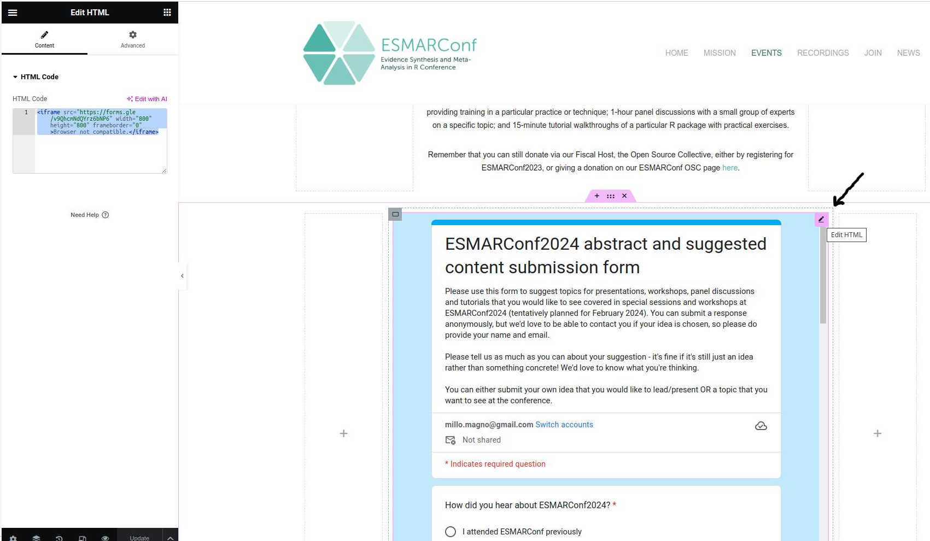Figure 2: Events Embedded Google Form

Follow Up Support
The above instructions should provide you with sufficient information to edit content in the ESMARConf.org site. For any questions or support you can email me, the developer on millo.magno@gmail.com, or message me via Telegram on +351 960.163.616.

